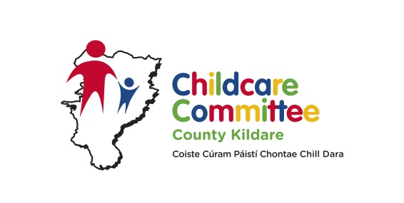

Bachelor of Arts in Applied Early Childhood Education & Care - Level 7 – Kildare 2018 – delivered in Carlow
Applicants Details
Name of Applicant:

Home Address:

Mobile No:

Email Address:

Employment Details
Place of Employment:

Address:

Telephone No:

Email Address:

Qualification
DCXXX or 6M2007
Please attach results/certificate/parchment of the FULL award

Course title Year Obtained

Accredited Training that you have participated in over the last 5 years
Please attached a copy of results for all listed below

Course title Year Obtained
Employment History
You may attach a CV in addition to the information given below
Employer & Address | From | To | Job Title | Role (please indicate what rooms you worked in)

LEVEL 7
Why do you wish to pursue this programme –Level 7 in Early Childhood Education & Care?

I wish to apply for the BA Applied Early Childhood Education & Care (level 7) award with IT Carlow & I give permission to IT Carlow to contact my employer in relation to the application if necessary.

Signed: ________________________________ Dated: ________________________

To be completed by your Employer

Is your service currently in receipt of the Higher Capitation for the ECCE Free preschool year?
(please circle)
Yes No

How many staff in your service work directly with children?

How many have ECCE Level 7+?

How many ECCE rooms operate in your service and at what times?

Room Session Time

Is the person applying for this training programme (Level 7) currently working in the ECCE room? (please circle)
Yes No

Will they be working in the ECCE room from Sept 2017? (please circle)
Yes No

Signed: Title:

Date:

PROGRAMME DETAILS STUDENT NO:

Programme Title: Bachelor of Arts Applied Early Childhood Education & Care –
Kildare 2018

PERSONAL DETAILS
Please Note: The name you enter will appear on any parchment to which you may be entitled to.
Surname ………………………………..First Name(s)…………………………………..
Home Address…………………………………………………………………………………
Name and Address of Service……………………………………………………………….
DCYA No.……………………………………………………………..
Do you have 3 years full time experience in the sector………………………………………
PPS Number …………………………………………………………………………………
Gender – Male/ Female …………………… Date of birth ………………………………….

Country of Birth…………………………….Citizenship ……………………………………..

Is English/Irish your first Language?
Home Telephone………………………………….Mobile Number …………………………...
Work Number……………………………..Email ……………………………………………..

Next of Kin……………………………..Contact Number…………………………………..

Have you previously been a student in IT Carlow? ……………………………………………
If yes please state course and Year ………………………………………………………..
QUALIFICATIONS
The following information requested is for admission and statistical purposes only and will be treated in the strictest confidence.
Indicate the last Educational Institution attended (i.e Secondary School, Irish University, Irish Institute of Technology, Post Leaving Cert college) ………………………………………

Indicate the Highest Qualification Achieved (i.e. Junior Certificate, Leaving Certificate, FETAC?NCVA, Apprenticeship, Ordinary Degree, Honours Degree, PLC Qualification, Masters) ………………………………………………………………………………….

Do you have a Disability/Specific Learning Difficulty? (Yes or No) …………………..
Please Note: that disclosure of a disability and/or specific learning will not adversely affect your application in anyway.

APPLICANT DECLARATION
I declare that the information given by me in this application is true and accurate and that if accepted I agree to read and abide by the regulations of Institute of Technology Carlow.
I hereby agree that the Institute may use my photograph in publications of the Institute where they judge this to be the best interest of either myself or the Institute. I understand that the Institute of Technology Carlow will treat all information as confidential and will not disclose such information except as permitted by Law. Other information provided will be held on computer and will only be used for purposes registered under the Data Protection Act.
Signed……………………………………………………..Date ……………………………

