Healthy Ireland Smart Start Health Promotion Programme
for
Pre-school Services

Developing Creative Confident Children

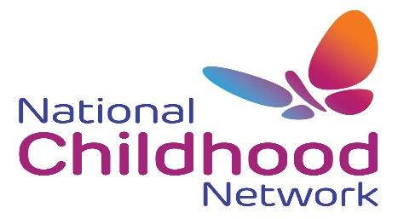
VENUE: Kildare Education Centre, Friary Rd, Kildare Town, Kildare.
DATES: Tuesday 28th April, 5th, 12th, 19th, 26th May, 2nd, 9th & 16th June 2015.
TIME: 7pm – 9.30pm.

C

DATES:
TIME: 7.00 p.m. – 9.30 p.m.
COST: €20

To book a place for your service please contact
NCN on 047 72469

Programme Content

- Developing a Health Promoting Pre-school Service
- Promoting Emotional Well-being/Literacy
- Nutrition / Healthy Eating
- Oral Health
- Physical Activity
- Health & Safety
- Preparing for External Assessment under the Healthy Ireland Framework

This programme will build on practitioners existing knowledge and skills to help services achieve the new Healthy Ireland Award for being a Health Promoting Pre-School Service.

The Programme is heavily subsidized by the Department of Health, through the Health Improvement Division of the HSE and supported by the Department of Education and Skills and the Department of Children and Youth Affairs.

To book a place please complete the attached application form and return to the NCN office by emailing info@ncn.ie

About the Programme

