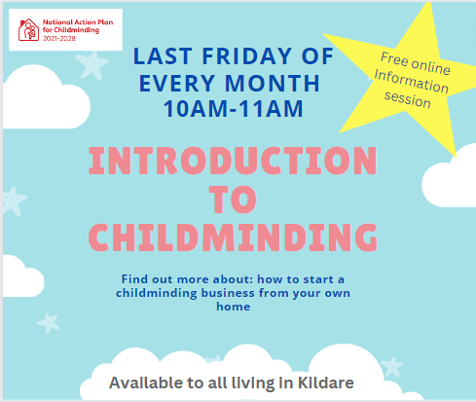

Do you enjoy being with children, helping them learn and develop?
Would you like to set up a childminding business at home but you're unsure about how to start?
Join our free webinar to find out more about childminding and some practical ideas about starting a professional childminding business that will have a positive impact on the lives of children. The online session will also provide an opportunity to ask questions to your local Childminding Development Officer who can support you on your journey.
This session is available to anyone living in Kildare.
F﻿or more information:
Please contact Louise: rcmdo@kccc.ie

